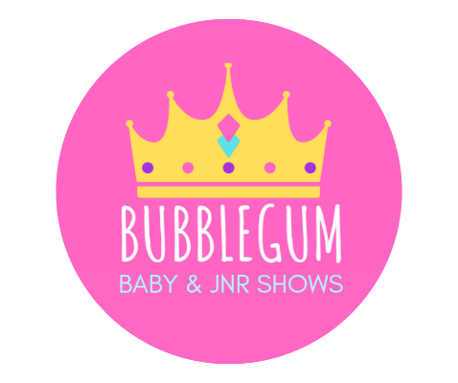
SPARKLE SCORE SHEET
CONTESTANTS NAME:
Contestants Age Group:
Contestants State:
Photogenic or N/A:

BUBBLEGUM POINTS SYSTEM – Each section judged 1-5
0 – Not able to be to be judged as is missing 3-4 Above Average fulfilment of requirements
1-2 Meets criteria for judging 4-5 Perfect fulfilment of requirements
2-3 Good Average fulfilment of requirements

All Bubblegum Contestants
Boho Chic
OUTFIT:
PHOTO CRITERIA FULFILLMENT:
BACKGROUND:
OVERALL:
DEDUCTIONS:
TOTAL:_________

Formal Wear
OUTFIT:
PHOTO CRITERIA FULFILLMENT:
BACKGROUND:
OVERALL:
DEDUCTIONS:
TOTAL:_________

PHOTO REQUIREMENTS
2x Photos, non professional photos in portrait LAYOUT
1x Mid-Head Shot and 1x Full Body Shot showing their outfit in full

Outfit– Boho Chic
​Girls & Boys : Linen, white and neutral tones, shoes on or off for this category only. Accessories welcome.
Outfit – Formal Wear
Full Formal in any colour and style the photo should be inspired by our theme costal couture non professional photo in portrait layout.
1x Mid-Head Shot
1x Full Body Shot showing outfit in full
​
PHOTOGENIC WINNERS - Baby and Juniors
All Photogenic of the month winners MUST provide 1 Mid Shot photo in their monthly winners sash that has their month title on it wearing their Royalty Wear.
This will be one of your Royalty wear photos and therefore only full body will also be required.

